1 )take two Machine

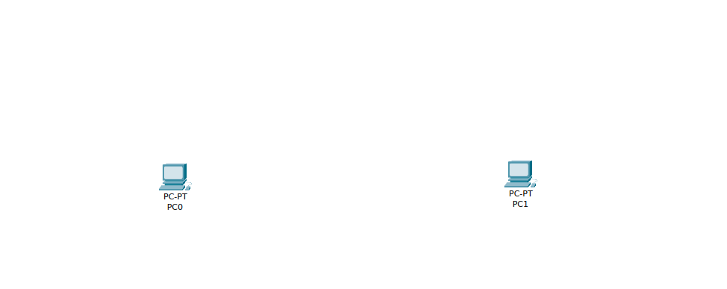
2

2) take one network device route

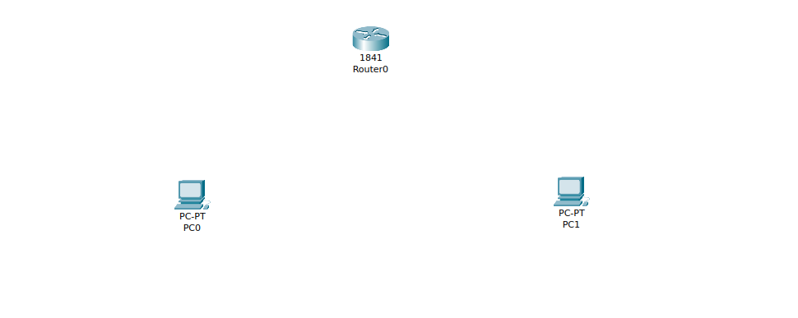
3) give connection

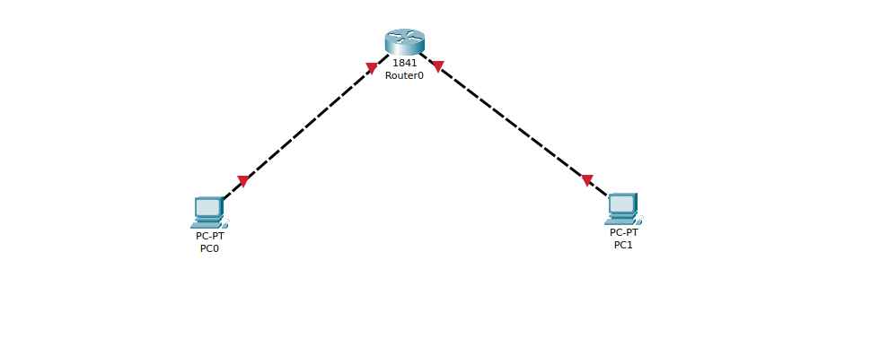
4)
set give ip addrea and default gateways for pc1 and pc2
for pc 1

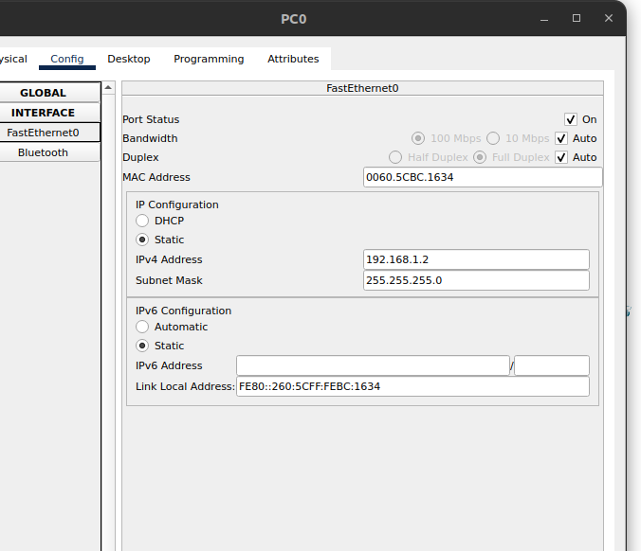
for pc2

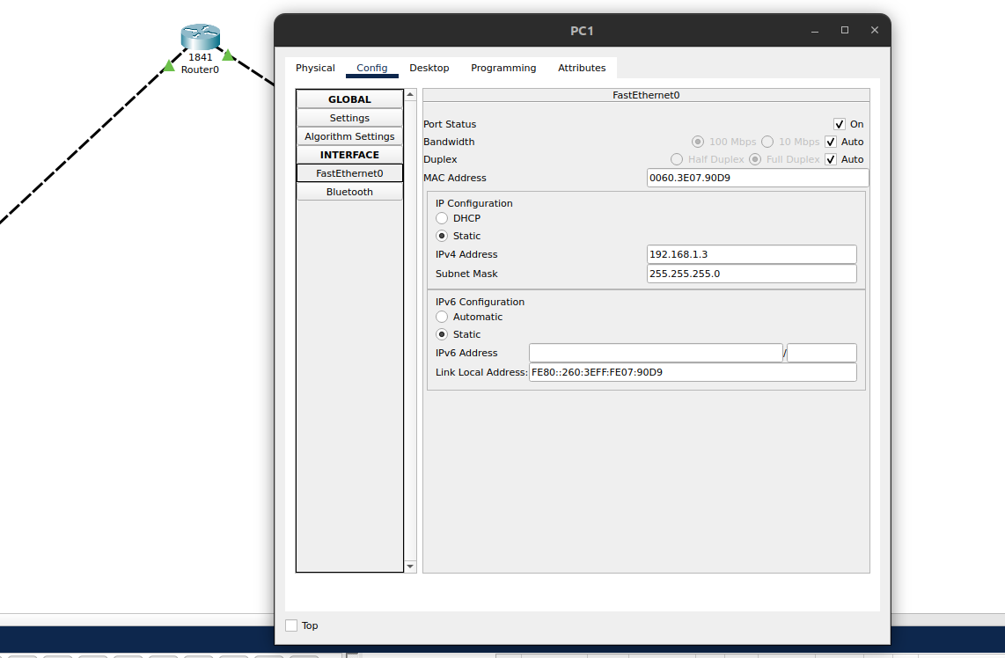
also set router from console

Router(config-if)#interface fa0/1
Router(config-if)#ip address 192.168.1.2 192.168.1.1
Bad mask 0xC0A80101 for address 192.168.1.2
Router(config-if)#no shutdown

Router(config-if)#
%LINK-5-CHANGED: Interface FastEthernet0/1, changed state to up

%LINEPROTO-5-UPDOWN: Line protocol on Interface FastEthernet0/1, changed state to up

Router(config-if)#
Router(config-if)#interface fa0/0
Router(config-if)#ip address 192.168.1.2 192.168.1.1
Bad mask 0xC0A80101 for address 192.168.1.2
Router(config-if)#no shutdown

